ADVENTURE WORKS · TECHNICAL SUPPORT

Squeaky, Dry Chain — Cleaning and Lubrication
Maintenance Document TS-015 Rev. A
Applies to | All Adventure Works models
Difficulty | Beginner
Time required | 15 – 30 minutes (plus dry time)
Tools needed | Chain lube (wet or dry), Degreaser, Brush or chain cleaner, Clean rags

Symptoms
- A squeak or chirp from the chain that rises with pedaling speed.
- A dry, rusty, or grimy-looking chain.
- Sluggish shifting and extra drivetrain noise.
- Black, gritty buildup on the cassette and chainrings.
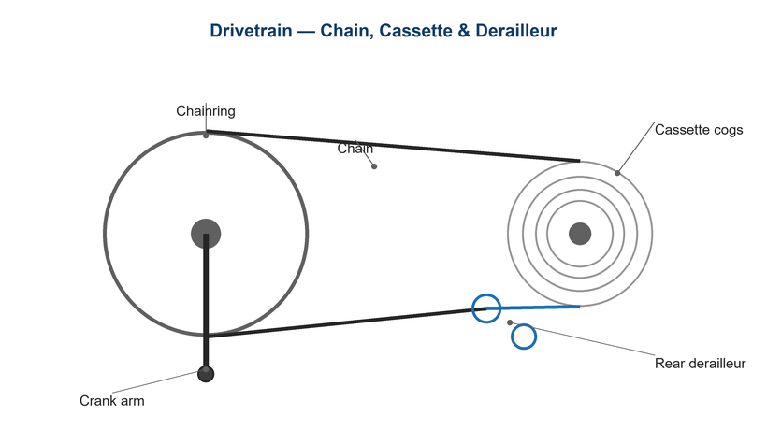
Figure 1. A clean, properly lubricated chain runs quietly and lasts longer.

Likely Causes
- Lubricant has worn off, leaving metal-on-metal contact.
- Riding in rain or dust stripped or contaminated the lube.
- Over-lubing attracted grit that grinds the chain.
- Using the wrong lube for conditions (dry lube in wet, or vice versa).
- A long-neglected chain starting to surface-rust.
Safety first
- Degreasers can be slippery and irritating — wear gloves and protect the floor.
- Keep lube and degreaser away from brake rotors, pads, and rims.
- Let the chain dry before applying lube, and wipe excess after.

Customer Fix — Step by Step
Suitable for home repair with basic tools. Work through the steps in order.
- Backpedal the chain through a rag to wipe off loose grime, then through a brush or chain cleaner with degreaser.
- Rinse lightly if using a wash-off degreaser, then dry the chain completely with a clean rag.
- Apply one drop of lube to each roller while backpedaling slowly — a full revolution or two.
- Let the lube soak in for the time on the bottle (often 5–15 minutes, or longer for wax).
- Wipe off all excess lube from the outside of the chain; only the inside needs it.
- Shift through the gears to distribute lube, then wipe once more.

Technician Reference
Additional checks and adjustments for service technicians and advanced users.
- Match lube to conditions: dry/wax lube for dry/dusty riding, wet lube for rain and long wet rides.
- For a deep clean, remove the chain via the quick-link and soak/agitate in degreaser, then dry fully.
- Inspect chain wear while clean; replace at the wear limit.
- Clean the cassette, chainrings, and jockey wheels — fresh lube on a dirty drivetrain wears fast.
- Consider a wax-based system for the cleanest, longest-lasting drivetrain if the rider maintains the routine.

Torque & Specifications
Item | Guidance
Re-lube interval | Every 100–200 km or after rain
Lube amount | One drop per roller
Dry time | Per bottle (5 min – overnight wax)
Dry lube | Dry/dusty conditions
Wet lube | Wet/muddy conditions

Figure 2. Apply lube to the inner rollers and wipe the outside clean.
Pro tips
- Less is more — a wiped-down chain stays cleaner and quieter than a dripping one.
- Re-lube after every wet ride to prevent rust forming overnight.

When to Visit a Service Center
- The chain is rusted into stiff links that won't free up.
- The drivetrain is worn and needs replacement.
- You want a professional ultrasonic clean and wax treatment.
- Noise persists after cleaning and correct lubrication.
This guide is provided for reference. Torque values are typical starting points — always follow the specific component manufacturer's instructions. © Adventure Works.

